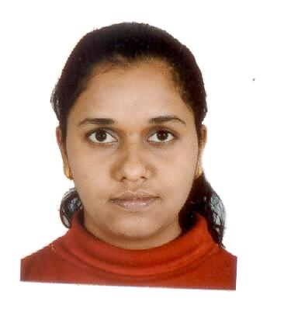**Name: Dr. Deepanjali Gurav**

**Photo:**

**Education: PhD**

**Email:** [dgurav@gmu.edu](mailto:dgurav@gmu.edu)

**Ph.D. thesis title:** Biopolymer based theranostic agents for anticancer activity and enzymatic stability

**Duration of research work:** January 2012- December 2015

**Publications earned during your tenure:**

1. **Deepanjali Gurav**, Anuja Kulkarni, Ayesha Khan, Vaishali Shinde, pH responsive sustained and targeted doxorubicin delivery using hyaluronic acid nanocarriers, **Colloids and surfaces B: Biointerfaces**, *2016*, 143, 352-358. (**IF=3.887**)
2. **Deepanjali Gurav**, Oommen P. Varghese, Osama A. Hamad, Bo Nilsson, Jöns Hilborn, Oommen P. Oommen, Chondroitin sulfate coated gold nanoparticles: a new strategy to resolve multidrug resistance and thromboinflammation, **Chemical Communications**, *2016*, 52, 966-969. (**IF=6.319**)
3. Mattias Tengdelius#, **Deepanjali Gurav#**, Peter Konradsson, May Griffith, Oommen P. Oommen, Synthesis and anticancer properties of fucoidan-mimetic glycopolymer coated gold nanoparticles, **Chemical Communications**, *2015*, 51, 8532-8535. (# equal author contribution, **IF=6.319**)
4. Jharna Barman, **Deepanjali Gurav**, Oommen P. Oommen, Oommen P. Varghese, 2′-*N*-Guanidino,4′-*C*-ethylene bridged thymidine (GENA-T) modified oligonucleotide exhibits triplex formation with excellent enzymatic stability, **RSC Advances**, *2015*, 5, 12257- 60. (**IF=3.108)**
5. Shujiang Wang, **Deepanjali Gurav**, Oommen P. Oommen, Oommen P. Varghese, Insights into the mechanism and catalysis of oxime coupling chemistry at physiological pH, **Chemistry- A European Journal**, *2015*, 21,5980-85. (**IF=5.317**)
6. Sougata Ghosh, Sumersing Patil, Niraja Chopade, Soching Luikham, Rohini Kitture, **Deepanjali Gurav**, Ajay Patil, Suvarna Phadatare, Vyankat Sontakke, Sangeeta Kale, Vaishali Shinde, Jayesh Bellare, Balu Chopade, Gnidia glauca leaf and stem extract mediated synthesis of gold nanocatalysts with free radicals scavenging potential, **Journal of Nanomedicine & Nanotechnology**, *2016*, 7:358. (**IF=3.573**)
7. Sougata Ghosh, Sumersing Patil, Mehul Ahire, Rohini Kitture, **Deepanjali Gurav**, Amit M Jabgunde, Sangeeta Kale, Karishma Pardesi, Vaishali Shinde, Jayesh Bellare, Dilip D Dhavale, Balu A Chopade, Gnidia glauca flower extract mediated synthesis of gold nanoparticles and evaluation of its chemocatalytic potential, **Journal of Nanobiotechnology**, *2012*, 10:17. (**IF=4.24**)

**Current Position:** Research Associate at George Mason University, Virginia, USA